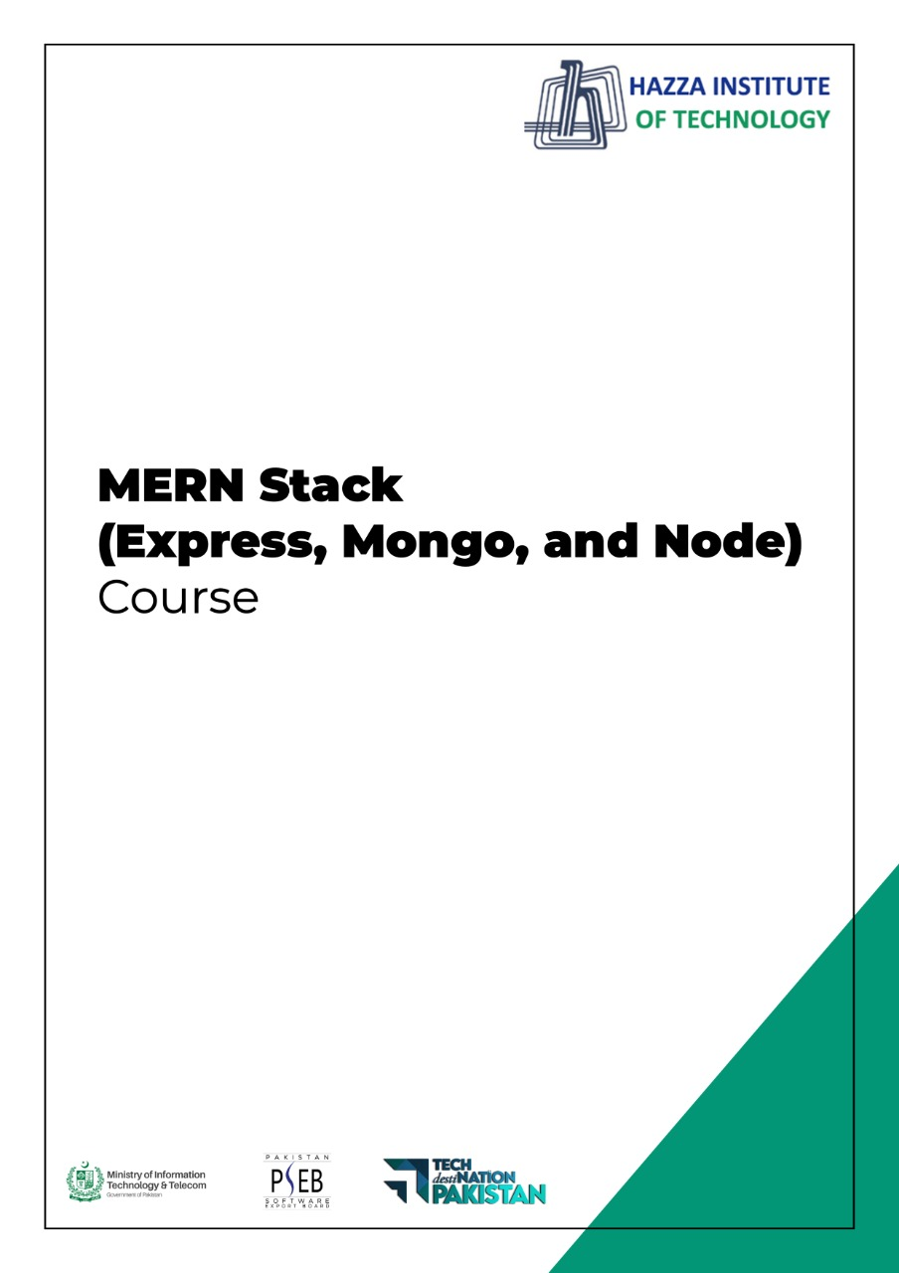

**Total Time:**

**3 hours**

**Pre-Lab Activities:**

* No Pre-Lab Activity

**Learning Outcomes:**

* Perform the execution, debugging, testing, and profiling of web apps in modern IDEs.

**Lab Tasks:**

* + Getting a text Editor
  + Installing Node in the local machine
  + Installing Express and React
  + Installing our database locally (MongoDB)

**Student Activities:**

* + To explore text Editor
  + To explore Node in the local machine
  + To explore Express and React
  + To explore MongoDB

**Lab Solutions:**

# Lab Tasks

# Getting a text Editor.

**System Requirements**

* Microsoft Windows 7/8/10 (32-bit or 64-bit)
* 4 GB RAM minimum
* 2 GB of available disk space minimum
* 1280 x 800 minimum screen resolution

**Step: 1 Getting a text Editor**

Any Basic text editor is needed to write the code and the command-line terminal is used to execute the code.

In this Setup, I use visual studio code as the text editor because it has several plugins and built-in terminal features.

Link :- https://code.visualstudio.com/

Download the code editor for your machine and for the specific operating system

*Note:-can use any text editor like

Atom

Brackets

Sublime text

# Installing Node in the local machine

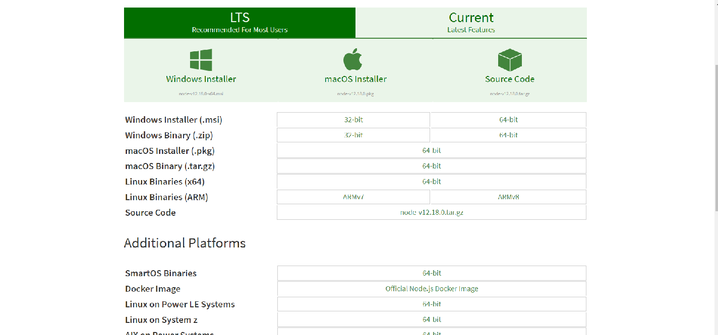

**Step: 2 Installing Node in the local machine**

Go to the official website for node js

Link:- https://nodejs.org/en/download/

LTS version is recommended for the beginner(fewer bugs). Downloaded the version as per the system.

And install the package and check that node is working all good.

To check the node js is installed open the command line and follow the below command.

C:\User\abc>node -v

Output:-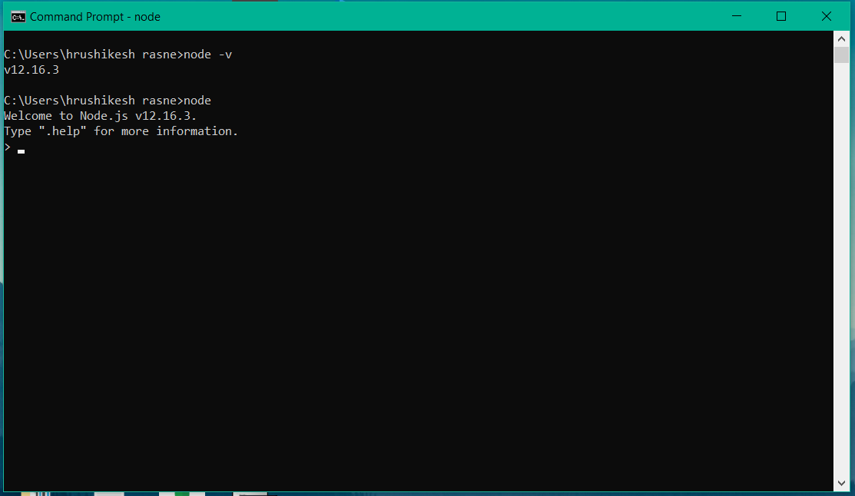

Thus our terminal is showing us the version and other options of node our installation has been successful.

# Installing Express and React

**Step:3 Installing Express and React**

As we First installed node js. A Software Registry is installed along with Node js. This Registry is known as npm Node Package Manager. That includes various open-source Libraries. It also contains express js.

Use the Command in the Terminal For installing express js package

C:\User\abc\Project_folder> npm install express –save

Express is installed and ready to use.

Use the following command to create a react app with all dependencies and support file

C:\User\abc\Project_folder> npx create-react-app folder_name

This command will download some dependencies and will create and run a default React app.

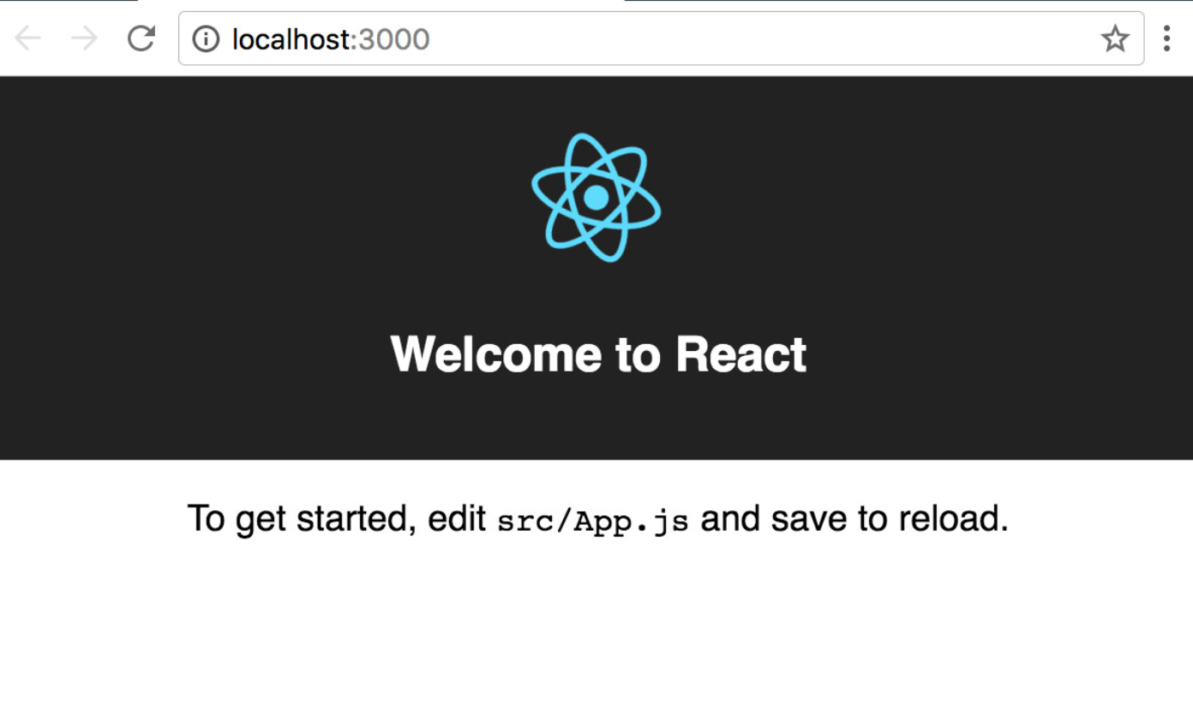

# Installing MongoDB

**Step:4 Installing Mongo DB**

Go to the official website for MongoDB and download

Link:- <https://www.mongodb.com/try/download/community>

After download click on the installer and after installation is over.

Open a command prompt and try the following command to check if the installation was successful use command.

C:\Program Files\MongoDB\Server\4.2\bin\mongo.exe

**Output:-**

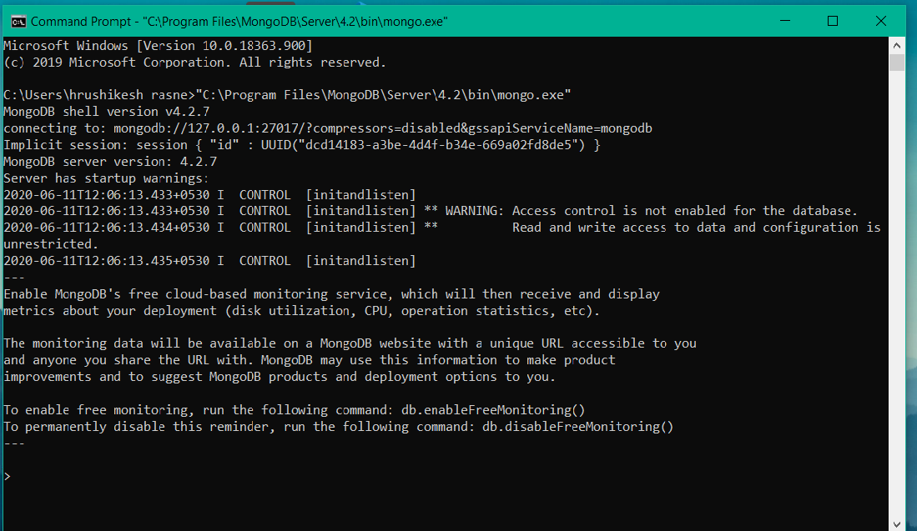

MongoDB provides the online server base database which can be used at production level or while hosting the Web application created using MERN.

Link:- https://www.mongodb.com/cloud/atlas

**Here the setup and installation of our MERN Stack are completed.**